Box 71589 NAIROBI EMAIL: imani@wananchi.com
COCTACT 0722 838 289 Website: www.imanikids.org
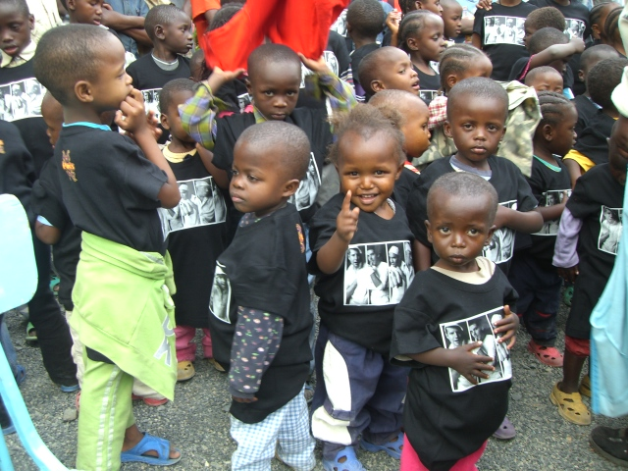

ANNUAL REPORT YEAR 2011
MANAGER’S DESK
The year 2010 was a tough year for us as even we approached the end of the year.
More so we managed to make a difference in the lives of many children in our centers and many families in the community. We supported children through child protection activities, education, primary health care, and lobbying for their support in general. Through adoption the process of adoption, a total of 27 children joined new families, 127 children also went back to the community through family re- unions. Many small babies were abandoned and there is a day that five babies were brought from different police stations after being abandoned by unknown parents. In total we rescued 31 new children into our program. Their age ranged from a day old to 3 years. This is a clear indication of the much work that is still unaccomplished in the community.
Last year 2010 we did a road show campaign awareness creation in our communities on children abandonment. We also had families’ empowerment programs in which we strengthened affected family units to be in a position to provide to their families as opposed to having them join the streets if not orphanages. Many projects were initiated like introduction of fish farming in Imani B and Imani Malindi respectively. There was also commissioning of Imani B kitchen, cabros project in Imani B and bio gas project in Imani B
On a different note we had sad moment in February Uncle Tom passed away. To the children he was a father, founder, uncle, guide and counselor. It was after a short illness and we are feeling the gap he left. Uncle Tom will be remembered for the incredible service to the children, we laid him to rest in peace on 28th Feb 2010. He was a family man with a son and a daughter and we felt we should extend our responsibility. We thank God for the many years he served the children. I am forwarding this important document to you – an annual report indicating what we did through you and others in 2010. We are really appreciating all our donors, Partners, well wishers and all our stakeholders at all the different levels for all the support they accorded us throughout the year 2010 and for all the areas that we were able to network. For sure were it not for your various inputs we could not have made it this far. We are also looking forward for your continued cooperation and support as we strive to ‘contribute into a society in which all children will lead a dignified existence with equal and just access to opportunities in life’. Wishing you a blessed new year 2011.
Yours in service,

Manager Imani Rehabilitation Agency

Imani objectives includes:
- To provide parental care and guidance to the children of Imani children’s home.
- To provide primary health care to the children of Imani children’s home.
- To provide quality education to the children at Imani children’s home.
- Capacity building Imani.
- Preventive activities in the community.

Rescue

Child abandonment still remains an issue to be addressed, even though Imani we are taking all measures to ensure that all is done to save life of these innocent little ones. At time’s babies reach to our home in at a state of life and death due to the conditions they are found in time of rescue after being abandoned. And a matter of urgent first aid has to be done immediately on arrival in order to save life.

Community resource mobilization

Running this noble task is not easy and in the process there are challenges. It is in this regard that we introduced different ways of mobilizing community for food baskets.
This goes along with the way the inflation is high which is making the cost of operation to be too high. And for us to be able to operate within the budget we have involved the community in giving out food stuffs.
Within a week we have set days in which we collect food baskets from the nearby markets to be able to feed these children. On Tuesday we receive from Corner Market, Wednesday Korogocho market, Thursday our immediate neighbors Soweto Slum, Friday Marigiti market and other traders call us for food baskets from time to time.
Empowering the lives of the families or guardians for these children will ensure that they are able to take care of the Children by providing the necessary ingredients for childcare in this respect; Imani organized a day and met with more than 300 members of Slum neighbors at Imani B where they shared nice meal together. The aim was to establish a forum to educate and build the capacity of the individual members. So much information was shared which culminated to the participants giving a lot of food in regular basis.
There after there was a coming together of all our local donors at Imani B for a celebration and an appreciation of their continued food basket all the year. This also marked the children Christmas party celebration.
Making children and the community aware of their rights greatly helped in the way children are viewed and considered in the modern society. All those involved were taught on the right of children .This will far much reduce the cases of child abandonment, negligence, assault and abuse.

OUT DOOR ACTIVITIES

During the year the children were busy practicing to hike mountains which took place in Mount Kenya. Practice was usually done twice in a month at mount Longonot and Ngong hills .The actual climbing date was 20th-26th December 2010. The flagging off of the hiker’s team was made by Pambazuko group foundation at Imani B. The goals are solely to raise funds for Imani recreation centre in Ngong and for children who require special treatment. This will provide new friends and provide unforgettable experience since this will be the second hike having climbed Mt. Kilimanjaro in 2003. The proceeds of Mt. Kilimanjaro were used to build a kitchen for the children at Imani A.
In this tournament some close friends of Imani have expressed interest in accompanying us during parts of the trip.

GIVE A CHILD A FAMILY IN THE RURAL AREA
Some have already committed themselves financially. Thanks for those who stood by us since the day of practicing to day of hiking by providing us with food, and even those who joined us to hike the mountain.
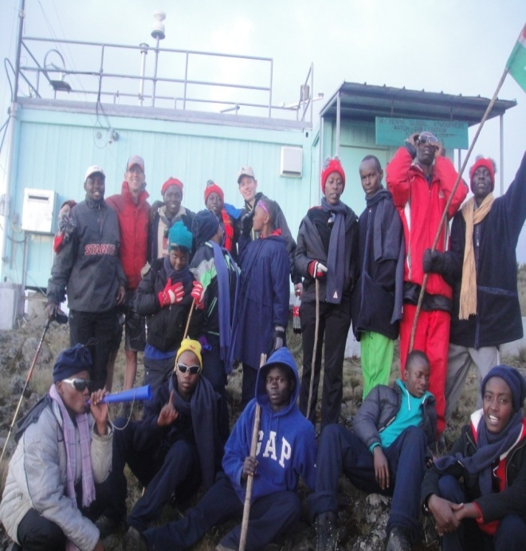

The project objectives:
- To seek kinship cares, foster parents, and community members willing and able to give orphaned children a family atmosphere and provide them with their needs.
- To ensure that orphaned child’s needs are met in their own communities, neighborhoods, schools, friends, churches and original social cultural environment (inclusive care as opposed to isolation in the institutions).
- To encourage community based care for orphans, and instill a responsibility of care for the vulnerable children in the community.
- To encourage de – institutionalization of children through reunification with families and cares within their natural environment.
- To promote scenarios where siblings are taken care of together within communities of their social cultural and ethnic origin without being separated or placed in unfamiliar environments.
- To promote the value of the family concept for orphaned children in the society.
- To raise awareness at all levels through advocacy and social mobilization to create a supportive environment for children and families affected by HIV.

CASE STUDY
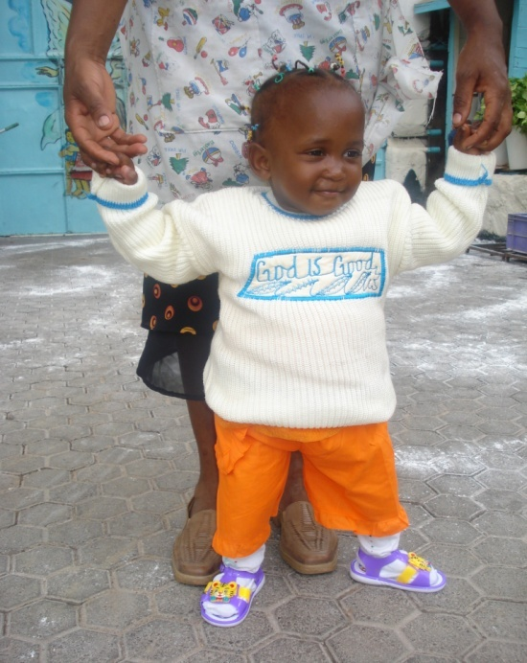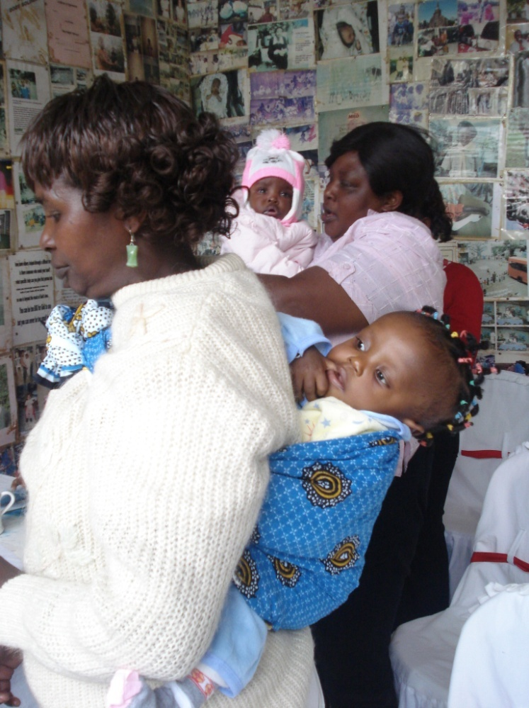
Every child has right to a family”- through the program (give a child a family) – children in need of a Family were placed with either adoptive or foster parents in need of a child
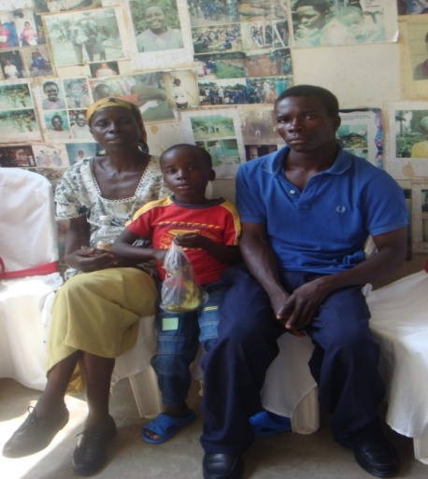
East or west home is best, thus we try our level best to ensure we afford our children the best home environment. We have started an incredible program for “giving a child a home at rural areas” whereby we are mobilizing potential parents to take up more children for foster care all over the country.
During the year we were able to reach out our children who are under foster care or undergoing pre- adoption bonding process. We were happy with the general progress of the children even though some cases were challenging to us. We have very many children all over the country and almost in every province. During the last year we went to Nyeri, Meru laikipia and parts of Nyahururu

Some of the results achieved:
- Value of the family concept for vulnerable children in the society being promoted.
- HIV/AIDS orphaned children happily settled in their natural communities, in extended families, or in foster families.
- Reduced rates of vulnerable children joining institutional care and only when it is the last alternative in the best interest of a child and under temporary basis.
- Community based concepts that are geared towards supporting and caring for vulnerable children incorporating rights based approach developed.

Challenges faced in social work department

- Increased numbers of lost and found children: this led to vigorous tracing activities and which made the fieldworkers transport expenditures rise.
- Increased cases of abused and neglected children in our program areas and with tedious court processes to be followed.
- Increased cases of child trafficking and which called for very careful measures especially when addressing new cases.
- 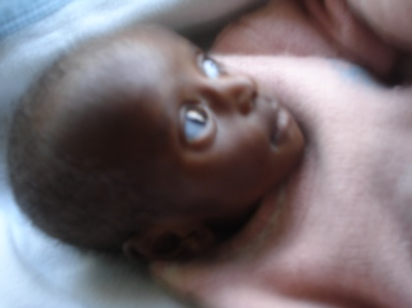

Case study 1: Prevention of family disintegration

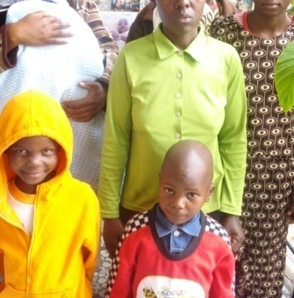

She started taking care of neighbor’s babies for a pay while their parents went to work. During the course of her duties her son ate the food that was brought in for a baby in her program. In her house there was no food to give to her client’s baby. As a result of anger she took a polythene bag and wrapped the hands of her son with it, she also sprinkled some paraffin on the polythene and as he was scaring his son with a lighting match stick the polythene caught fire and burnt his son. On top of his yelling voices neighbors streamed into their house to rescue. She was thoroughly beaten by the angry mob and who wanted to protect the right of the child. Later she was taken to the police custody.
At Imani
- Her 4 children were brought to Imani children’s for temporal care and protection, including the breastfeeding one.
- On assessing the children plight, they all looked strong and healthy - an indication that the mother was at least trying to make ends meet.

Thought for Imani
- That institutionalizing the children while the mother is jailed is not a permanent solution and taking into consideration of the best interest of the children.

- Therefore we carried out a home study and learnt that the young mother was a widow. That she had differences with her in laws and which led to her relocating to Nairobi. That while at Nairobi she brought up her children with a lot of strains and while begging mercies of others.

- We intervened and requested the authority to allow us give her a community service order at Imani children’s home where she can also get into contact with her children, where we can counsel and rehabilitate her and together have a plan for the children’s future. This was accepted.

Today
Jennifer is a happy mother, equipped with skills in child care.
- She is also resettled back to the community and leading a normal life.

- She has also managed to secure a job and through which she is able to provide for her children.

- She has reconciled with her extended family and who are also exercising custody of her first 3 children.

- Through Imani the family was not disintegrated instead it was strengthened to be better able to take care of its members.

Jennifer’s family is one of the 7 families that we saved from disintegration based on desperate life issues.

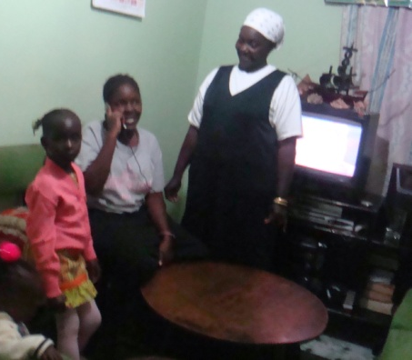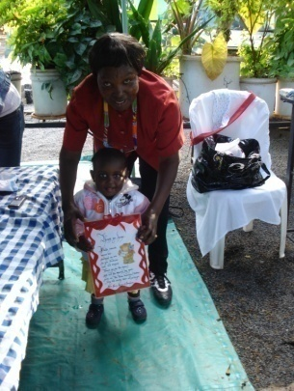

Family re-unions
The ultimate goal is to ensure families continue to succeed and do take care of their children. As Imani we are obliged to take all the precautionary measures. The social work has a program in place to ensure adequate follow-ups.

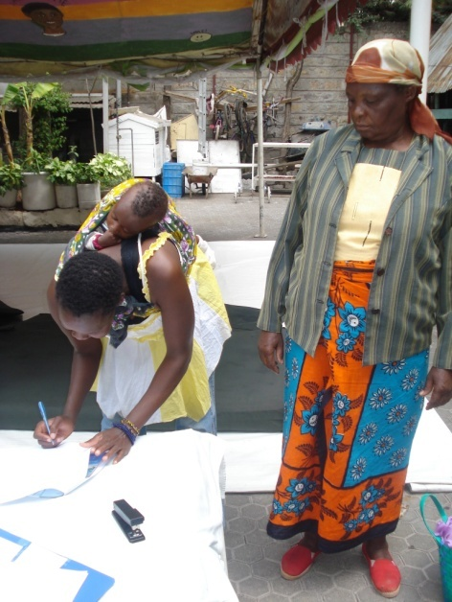
Apart from rescuing the vulnerable children we also worked hard to address the root causes of their problems. Some of the children rescued abandoned were found to have other issues surrounding their fate e.g. Children abandoned by traffickers after their mission fails and also those who got lost. It was quite an involving task trying to trace the possible families and their whereabouts and which involved working closely with police stations, local leaders, and the media.

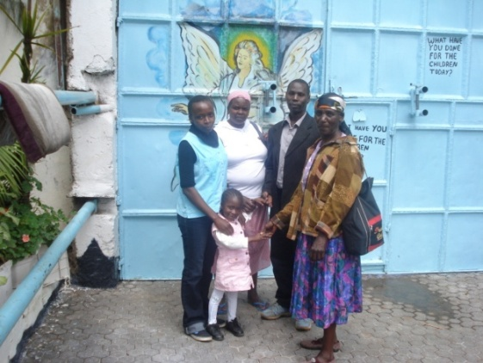
In other scenarios children were re-integrated with their families after situations back at home improved and with responsible guardians having been trained, and prepared for the reunification. In total during the third quarter 21 children were successfully rejoined with their families

REAL TESTIMONIES
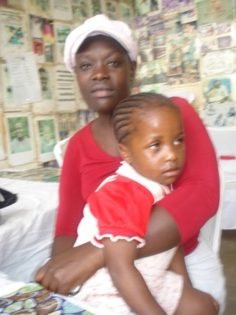
“My daughter it is more than 3 months since you left me. Life has been hard without you by my side, in many police stations – I have gone searching for you. I have approached every known pastor just for prayers- to have me see you again”.
Thank you Imani for saving the life of my only daughter after she lost her way home months back.
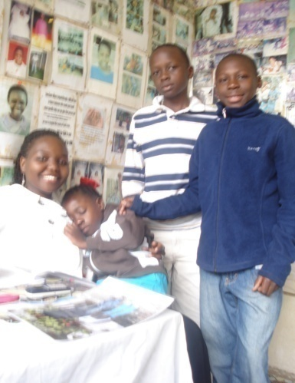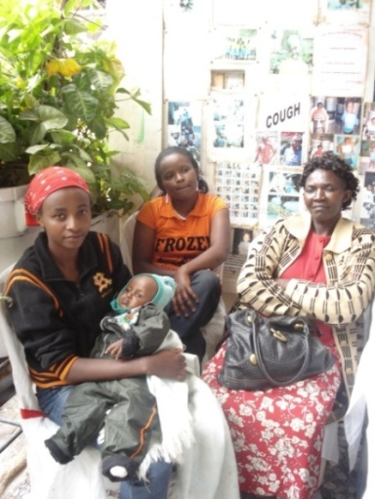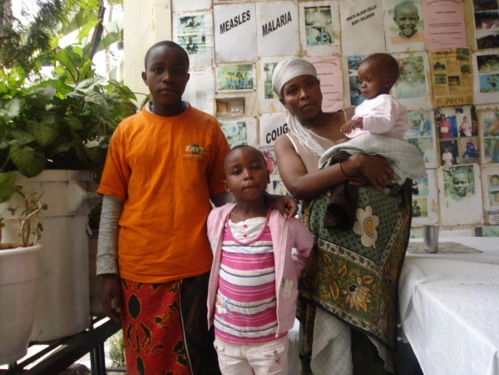

Adoption

The main aim why we admit new born babies is to offer temporally shelter, food, love, care and protection. When these babies are free from any legal bindings, we offer them for adoption. The attitude in Kenya is changing for many couples are embracing adoption. This is a culmination of proper net working with adoption society and lawyers.
Despite the many hurdles the adoption process is in the process of being streamlined. The opening of Imani B hall paved way to an adoption ceremony on the 7th march 2010. Imani was enabled by the grace of God to adopt out ten angels to new families. The occasion was marked with tears of joy, separation and love from both new parents and Imani family.
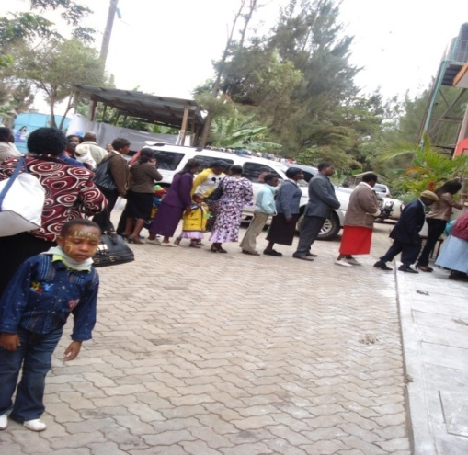

Health care
Health care remains one of the most essential needs to be addressed in any environment like this. As majority of you are aware we have a couple of medical challenges among our children indeed requiring foreign attention.
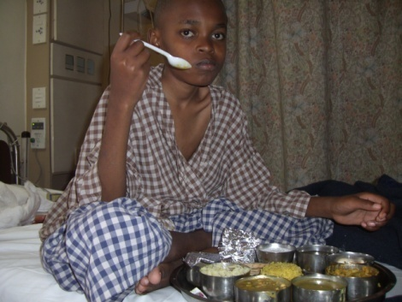
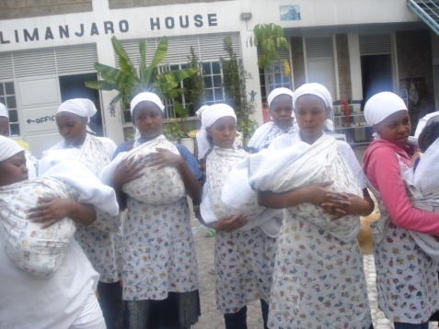
The Board has enabled us raise a fund kit for this purpose. In March Mathias went back to India for medical checkup where he stayed for 2 weeks. He was undergoing physiotherapy and has made exciting improvement in his walking and balance. Thank you all for your support and care God Bless.
During mid of the year we experienced quite a number of challenges in health and this was because of the cold weather season. As a result we had many pneumonia cases and this was worse for the small babies who were abandoned on the cold streets, roadsides, bushes and in paper bags , without clothing for some cases. Painful to remember is that we lost a new born immediately after arrival at Imani as a result of having spent a night in the cold and having lost alsmost all the reflexes.
We also experienced several cases of colds, and skin infections. We had to fight back with the adverse weather conditions by dressing the children warmly, using the cold liver oil every morning and evening for the small ones, and taking the little babies ones out only when the weather was condusive.
In place we had a visiting Doctor twice a week, we also had visiting Doctors twice in a month, a full time nurse and we maintained a close network with various hospitals which included :- Kenyatta national hospital, St. Mary’s hospital, Getrude’s garden hospital, Divine health centre and Nairobi women women hospital and where we referred the cases which were above in house attendance.children with chronic illness continued with their routine check ups, review clinics and medication. They were also of diffrerent categories and which were as follows:- 2 epileptic cases, 8 children on Anti Retro Viral treatment, 3 children on tuberculosis treatment ,one child with cleft palate and heart condition, and 4 children who have chronic otitis.
There was also timely immunization for our children against various diseases.
Having a full time nurse in our centre, we had volunteer doctors visiting from st Mary’s hospital once in a month and also a clinical officer who attended children once in a week from Divine word parish.
We also had some other hospitals in network like Kenyatta national hospital for referrals, Nairobi women’s hospital not forgetting Mater hospital which undertook care of one of our child who had heart problem.

Education

We are conscious of the fact that education is the key to success subsequently we give it priority. Despite the financial constrain we try our level best to give our children the best. Children are assisted in their studies by a teacher and those in higher grades also assist with homework. As a result performance has greatly improved. We invest in their education as an inheritance to them. Besides formal education we extend good manners and etiquette to our children.
Since education is the key to success for a better future, we at Imani are in front line in realizing this by making sure each and every child access quality education regard less of financial constrains we are experiencing. The children continued working hard in their various schools and levels. And this has been proven through records where our children from Imani dominated position 1-10 in most of the schools they are attending. The best performers in 1st term of the year were also rewarded accordingly.
A number of schools also sponsored children in their schools and where they met their tuition fees. Of importance to note is that 4 children had their school fees paid by well-wishers and who acted as their distant foster parents- a move which enabled them to be able to get quality education.

Computer lessons

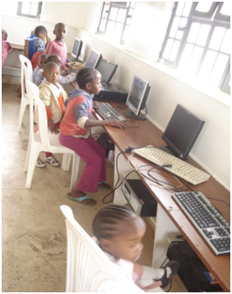
On weekends children were involved in computer classes as a way of learning modern technology and in line with the government vision 2030. During computer classes children are able to access MSINGI PACK software which guides them in structured questions and answers, through the program they also learnt the aspect of managing time in an exam of importance it became a fun way of learning and covering their school syllabus.
Musingi Park has necessitated our children to do through revision which has shown a lot of progress and improvement in this year final exam.

Counseling and psycho social help
Counseling is a vital program in any institution, it helps resolve intra personal conflicts and also gives an opportunity for the children to learn, understand and relate to themselves.
Children received counseling either at personal level or as a group.
Personal counseling was done to children, who have shown signs of stress like isolation, aggression or any prosocial behavior. Most children especially the older ones have become better time managers since they now know the cost of wasting time.
With the lessons on self esteem most children had a reason to smile, pray with others and even value themselves which has given them peace and happiness to be what they are destined to be.
We expanded the children group counseling sessions. In 3 days per week all children were able to access counseling services. This has gone a long way in improving the children conduct both at home and while in the large society.
The counseling for the children also continued with internal and external counselors. It was also possible to address the children issues in good time and even to help them settle down well and especially for the newly admitted or undergoing psychological trauma.

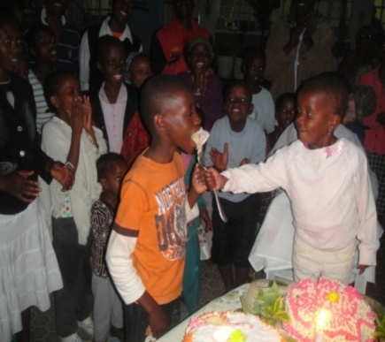
Birth days

As a way of motivation and encouragements for our children to feel at home rather than an institution there is usually preparation of birthday’s celebration. During this year we have been able to organize several birth days for our children who have attained different ages at different centers.

Capacity building

We had various capacity building activities that were geared towards building the capacity of the Imani staffs as well as the voulnteers. The capacity building sessions were mainly in form of seminars and workshops organized both indoors and out doors. Among the areas that more emphasis was put were in
- organization culture and behaviour change.
- regulations governing charitable children organisations.
- Alternative care for ophans and vernarable children.
- Child rearing practices.
- Understanding team weaknesses and strengths.
- Child counselling techniques.

Volunteer staff

35 volunteer staffs’ especially young people from both local and international learning institutions came to give a hand in all our program areas. They did well in the areas where they were placed and so the many babies felt a warm touch which is also very important in their growth and development.
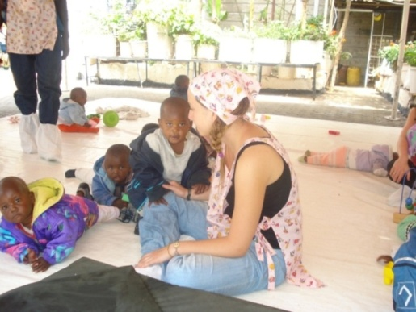

The board meeting

The Board provides the general direction, guidance and support, and also monitors the activities of Imani to be at the best interest of the children. During the year the board met at different times to deliberate on key issues and proper management and evaluation of the project. On the other hand we lost the secretary to the board Mary Mwangi she was a committed lovely mother both to the children and her family. The entire Imani really feels the gap that she was occupying.

Animal Farm

Bearing in mind the nature of children that we receive here in Omani, besides the parental care that they miss their immune system is usually very low. And the only way to boost their immune is by having livelihood programs where we have animals that provided us with primary animal products. Eggs, milk and rabbits meat. Our animals are doing quite well and they have continued in giving us food. Their manure has also contributed very much to our kitchen gardens and which produces vegetables throughout. In addition the dun from the cattle farm is used as a primary input of our biogas digester. The fish project is also doing well a project that has also been introduced in malindi. In addition we introduced guinea fowls in our poultry farm which are also doing quite well.

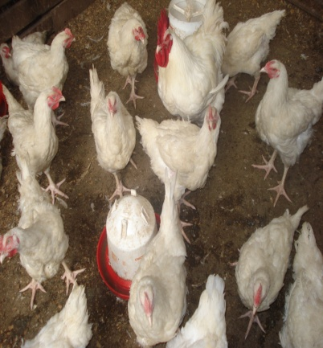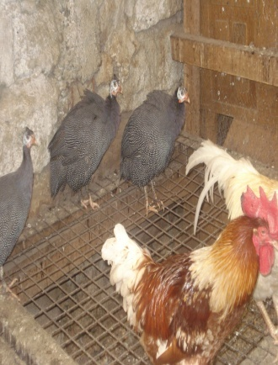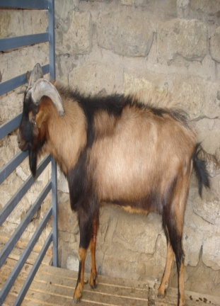

Opening Imani B kitchen
A colorful and exciting ceremony marked the official opening of our new building on March 2010. The building was donated by donors from the Netherlands and named after JAANTJE VAN ARKEL. It was commissioned by Dr Michael D Johnson FACS and Mrs. S. Kay Johnson of world Gospel Mission Nairobi Kenya. The new premises comprise of an ultra modern kitchen, dining hall, library/ computer room, offices, stores and a clinic. Fifty chairs were purchased for the use in the new dining hall. The building structure have incorporated the use of biogas and solar in the near future. Our former strategic partners International Child Support came on board to assure us the good job we are doing and celebrate the many years we had worked together.

Biogas project
The Biogas project in Imani B has been fully constructed and certified; now we have an opportunity to save energy as we are now using biogas to cook.

SOLAR SYSTEM IMANI B

The solar system has been fully installed and is operating on well. Now we have hot water system used when cleaning the utensils which has made us maintain and improve our hygiene.
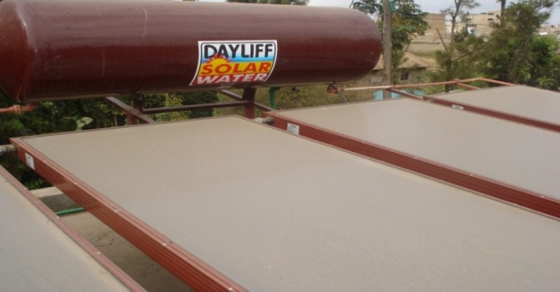

CABROS PROJECT

Cabros in Imani B has been fully carpeted now we have a clean environment dust free for playing and walking through.

FUTURE PLANS
Emphasis on give a child a rural home, hence this will reduce cost of institution care for the children as well as give them a belonging in their own communities.

Looking for an income generating activity to complement our operational and food budget.
To promote scenarios where sibling are taken care of together within communities of their social cultural and ethnic origin without being separated or placed in unfamiliar

VOTE OF THANKS.
To achieve the various activities we had networks and partners at different levels and who included FEMI, QUACK FOUNDATION, WERELDKINDEREN, JOHN VOLKEN FOUNDATION, IMANI FOUNDATION, the children department, adoption societies, Kenya Christian homes, Kenyans to Kenyans and the Child welfare society of Kenya, the area advisory committee, African chapter for prevention and protection of child abuse and neglect ( APPCAN), Red cross society of Kenya, local administration, health facilities, academic Institutions, VEGPRO, Child life trust, Health facilities, Media, the juvenile court, Well wishers and the churches.
To all our networks, we really appreciate your kind support in bringing a smile in life of many children and families in need. Bravo again for making a choice to contribute into a society where all children will lead a dignified existence while growing up, with an equal and just access to opportunities in life.
Thank you all.

